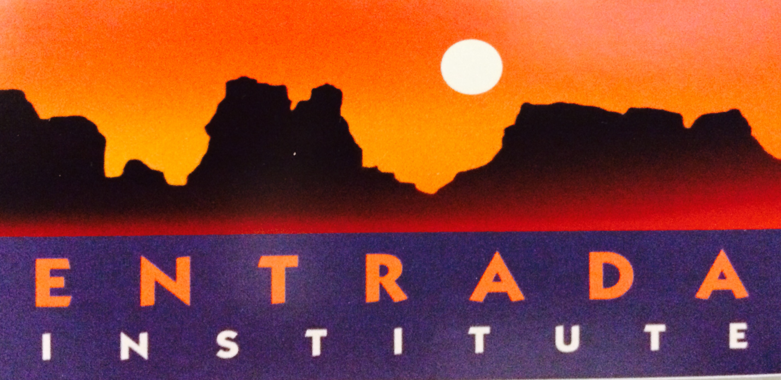

2nd Annual Arts and the Park - “Light on the Reef”

artsFUSION Youth Workshop Registration and Waiver of Liability Form
The attached form must be completed and signed by both parent and youth and returned to the youth's art teacher in order to register for a youth workshop. If school is no longer in session, please mail the attached form to PO Box 368, Torrey, UT 84775 no later than June 1st. Late registrations may be available on site, on a first come first serve basis, on the first day of the events.

WHO ARE WE
The Entrada Institute was established in 1993 as a 501(c)3 non-profit corporation to support artists, writers, humanities scholars, earth and social scientists in their development of new works, and promote understanding and appreciation of the natural, cultural, and historical heritage of the Capitol Reef area. Entrada’s programs and youth scholarships are supported by personal and corporate donations, grants, and modest admission fees to some events.

WHAT WE DO
Entrada is a Spanish word that means “opening” or “gateway.” It is also the name of a spectacular geologic formation on the Colorado Plateau. Fittingly, the Entrada Institute, headquartered in Torrey, Utah has opened the door for people of all ages and diverse backgrounds to come together through its eclectic events. Programs are designed to entertain, inform, and interpret the area through art, humanities and science. The Entrada Institute brings both emerging and highly experienced visual artists, authors, composers, earth scientists, astronomers, filmmakers, historians, photographers and many others together to help combine people, places, and experiences in the visually stunning surroundings of Capitol Reef National Park in Southern Utah.

ARTS AND THE PARK
Arts and the Park is a program presented by the Entrada Institute, Inc., in partnership with the National Park Service, Capitol Reef National Park, Capitol Reef Natural History Association, Gallery 24, The Torrey Gallery, Torrey Town, Utah Travel Council, Utah Water Color Society; and many other youth arts education sponsors including Bad Dog Arts. Arts and Park “Light on the Reef” is intended to be an experiential plein air event for the whole family; it celebrates first steps into arts education and natural sciences while celebrating life-long learning and the creative spirit of the people and the place that is the Colorado Plateau.
http://www.entradainstitute.org

Color Splash Grades 1-6 • Friday & Saturday June 12 & 13 • 9:00 am - 4:30 pm
Be inspired by nature in the park while learning a variety of painting and printmaking techniques. Day one will be a fun, fast-paced exploration of stamping, stenciling, spraying, and layering. We will discover how to harness the power of the sun to create wonderful high-contrast images. Day two kids will learn to paint with Egg Tempera and practice some of the processes learned on the first day.

Earthworks Grades 7-12 • Friday & Saturday June 12 & 13 • 9:00 am - 4:30 pm
Learn how artists have created monumental sculptural art from natural materials such as leaves, rocks, sticks, dirt, and even ice & snow! Viewing a film that features famous artist Andy Goldsworthy will first inspire us. On day one, teens will hike, sketch and participate in a variety of art making activities. On day two they will participate in a collaborative process to build their own amazing earthworks installation.

General Information for Parents Each day everyone will meet at 9:00 a.m. at the Ripple Rock Nature Center in Capitol Reef National Park and then will split off into their separate groups. You will need to bring a lunch and refillable water bottle each day. Snacks will be provided in the morning and the afternoon. If your child has food allergies you may want to provide his/her own snack. Wear sunscreen, bring a hat, and wear closed toed shoes. There is no cost to participate but each child must be pre-registered to participate. Sign up is on a first come first served basis. Space is limited to 20 participants in each of the programs above.

2015 - artsFUSION Youth Workshop Registration and Waiver of Liability Form

Registration Please complete one form per child

Rules for Youth Participation

- I will remain at the assigned event site once an activity starts unless parental permission for early departure is provided to an Entrada Institute, Inc., artsFUSION leadership or volunteer staff partner..
- I will act with trustworthiness, responsibility, and respect toward all participants as well as Entrada Institute, Inc. or artsFUSION leadership or volunteer staff partners.
- I will be aware of my personal safety and the safety of other participants.
- I will use appropriate language and respect the rights of others.
- I will be respectful of public or private property and will be responsible for any damage, theft or misconduct.
- I will not behave recklessly, nor harm another person.

I agree to follow these rules:

Print Name: ____________________________________________ Youth’s Signature: ______________________________________________

Grade:______________________ Color Splash Participant:_____ or Earthworks Participant_____

Parental Permission and Waiver of Liability

- I give my permission for my child _______________________________ (insert name) to participate in the Entrada Institute Inc. and artsFUSION - Youth Arts Workshops at Capitol Reef National Park’s Ripple Rock Nature Center on Friday, June 12 and Saturday, June 13 as denoted in the program schedule and descriptions.
- My child and I have read and understand the rules applicable to his/her participation. My child understands it is his/her responsibility to follow these rules and any other directions provided by the Entrada Institute, Inc., Capitol Reef National Park and/or Bad Dog Arts.
- While there will be adults present at the event, I further understand they are not responsible for supervising my child either before, during or after these workshops.

I have read and understand the waiver of liability below:

“I assume all risk of personal injury including death and damage to personal property that may be sustained by my child while attending and/or participating in these events. I release the Entrada Institute, Inc. and artsFUSION, including any unit or Division thereof, from any and all liability for any injury, death or damages that my child may suffer whether due to the negligence of the Entrada Institute, Inc. and artsFUSION, their respective agents, employees or volunteers. I also agree to defend, indemnify and hold harmless the Entrada Institute, Inc. and artsFUSION and its directors, officers, employees, partners and volunteers from and against any and all actions, suits, claims, demands, causes of action, proceedings, losses, costs and expenses including and without limitation all attorney fees and disbursements, damages, liability and fines or penalties in any way arising out of, or relating to, or connected with directly or indirectly, my child’s participation in this event regardless of whether there is active or passive negligence or fault on the part of the Entrada Institute, Inc., artsFUSION or other released parties.”

Date: ___________________________________

Parental Signature(s): _______________________________________________________________________________________
Print Name(s): _____________________________________________________________________________________________

Parental email and phone number: ____________________________________________________________________________

Contact Us:
Marci Milligan, Event Co-Chair at marci@lotuscdcs.org or call 801-509-1289
Leah McGinnis, Event Co-Chair at leah_mcginnis@nps.gov or call 435-425-3791

